ECON 101 – Macroeconomics
MIDTERM EXAM #2
EXAMINER: MUHEBULLAH KARIMZADA
November 05, 2025

Instructions:
1. You have 75 minutes to work on the exam.
2. This midterm is individual and closed-book.
3. For the multiple-choice questions, choose the option that best answers/completes the question.
4. This Examination paper includes 14 pages (includes the cover page). You are responsible for ensuring that your copy of the paper is complete. Bring any discrepancy to the attentions of your invigilator.

PLEASE: PUT YOUR NAME AND STUDENT ID ON EVERY SHEET!!
Multiple Choice Answers:

1. _________ 15. _________ 29. _________ 43. _________ 57. _________

2. _________ 16. _________ 30. _________ 44. _________ 58. _________

3. _________ 17. _________ 31. _________ 45. _________ 59. _________

4. _________ 18. _________ 32. _________ 46. _________ 60. _________

5. _________ 19. _________ 33. _________ 47. _________ 61. _________

6. _________ 20. _________ 34. _________ 48. _________ 62. _________

7. _________ 21. _________ 35. _________ 49. _________ 63. _________

8. _________ 22. _________ 36. _________ 50. _________ 64. _________

9. _________ 23. _________ 37. _________ 51. _________ 65. _________

10. _________ 24. _________ 38. _________ 52. _________

11. _________ 25. _________ 39. _________ 53. _________

12. _________ 26. _________ 40. _________ 54. _________

13. _________ 27. _________ 41. _________ 55. _________

14. _________ 28. _________ 42. _________ 56. _________

MULTIPLE CHOICE. Choose the one alternative that best completes the statement or answers the question.

1) You agree to lend $1,000 for one year at a nominal interest rate of 10%. You anticipate that inflation will be 4% over that year. If inflation is instead 3% over that year, which of the following is true?
A) The person who borrowed the $1,000 will be worse off as a result of the unanticipated decrease in inflation.
B) The purchasing power of the money that will be repaid to you will be lower than you expected.
C) The real interest rate you earn on your money is lower than you expected.
D) The unexpected inflation has increased the opportunity cost of making the loan.
E) The real interest rate you earn on your money will be negative.

2) The "new product bias" in the consumer price index refers to the idea that
A) consumers prefer new goods, even if they are worse in quality than old goods, and this causes the CPI to underestimate the cost to consumers.
B) new products' prices often decrease after their initial introduction, and the CPI is adjusted infrequently and overestimates the cost to consumers.
C) new products are often over represented in the basket as consumers move quickly to adopt new technology and then buy fewer units as time passes.
D) consumers switch to old goods when the prices of new goods increase, and the CPI underestimates the cost to consumers.
E) consumers switch to new goods when the prices of old goods increase, and the CPI overestimates the cost to consumers.

3) You earned $30,000 in 2010, and your salary rose to $80,000 in 2020. If the CPI rose from 82 to 202 between 2010 and 2020, which of the following is true?
A) The purchasing power of your salary increased between 2010 and 2020.
B) There was deflation between 2010 and 2020.
C) The purchasing power of your salary remained constant between 2010 and 2020.
D) The purchasing power of your salary fell between 2010 and 2020.
E) There is no way to compare the purchasing power of your salary between 2010 and 2020.

Table 5.14
Year | Nominal Average Hourly Earnings | CPI (2002 = 100)
1956 | $1.53 | 14.3
2020 | 25.14 | 127.3

The table above reports the nominal average hourly wage and the consumer price index for 1956 and 2020.

4) Refer to Table 5.14. The percentage change in real average wage from 1956 to 2020 equals
A) 2.0 percent.
B) 8.7 percent.
C) 21.7 percent.
D) 84.6 percent.
E) 154.3 percent.

5) Inflation is measured
A) as the percentage change in the consumer price index.
B) as the change in the value of the Canadian dollar.
C) using the level of the consumer price index.
D) using the level of real GDP.
E) as the percentage change in real GDP.

6) ________ is the ease with which a financial security can be exchanged for another.
A) The face value
B) Liquidity
C) Convertability
D) The rate of return
E) Risk

7) People born in wealthier countries can expect
A) to live shorter lives than those born in poorer countries.
B) to live shorter lives than those born in the same country 40 years ago.
C) to live longer than those born in poorer countries because wealthy countries can provide more health care.
D) to live just as long as those born in poorer countries because wealth and life expectancy are unrelated.
E) to live shorter lives than those in poorer countries due to the pollution associated with economic activity.

8) In a closed economy, which of the following components of GDP is not included?
A) government spending
B) taxation
C) consumption
D) net exports
E) investment
9) The output gap is
A) a measure of potential output.
B) negative if potential GDP is larger than real GDP.
C) negative if potential GDP is smaller than real GDP.
D) constant throughout the business cycle.
E) shrinking all the time.

10) When the economy enters a recessionary phase of the business cycle, unemployment tends to
A) increase.
B) decrease.
C) be unchanged.
D) change in the same direction as the rate of inflation.
E) change in the same direction as the labour force participation rate.

11) Financial securities that represent promises to repay a fixed amount of funds are known as
A) insurance premiums.
B) preferred shares.
C) bonds.
D) stocks.
E) pension funds.

12) Which of the following statements describes the experiences of Bombardier since it was established in 1942?
A) growth interrupted by periods of business cycle recession
B) little or no growth in the long run, and unaffected by the business cycle
C) continually shrinking demand for its products
D) little or no growth in the long run, but very vulnerable to the business cycle
E) strong uninterrupted growth in demand

13) Since 1980,
A) the Canadian economy has spent equal time in recession and expansion.
B) the Canadian economy has experienced almost no economic growth.
C) the Canadian economy has spent more in time in recession than expansion.
D) the Canadian economy has spent more time in expansion than in recession.
E) the Canadian economy has experienced one long depression.

14) Increases in real GDP since 1961 can actually underestimate growth in the standard of living for Canadians because
A) the level of pollution in 1961 was much higher than it is today.
B) the quality of health care that exists today was not available in 1961.
C) goods and services are more expensive today as compared to 1961.
D) fewer women participated in the paid labour force in 1961.
E) the crime rate was higher in 1961 than it is today.

15) If labour productivity growth slows down in a country, this will
A) slow down the increase in real GDP per capita.
B) slow down the increase in nominal GDP.
C) accelerate the increase in nominal GDP.
D) accelerate the increase in real GDP per capita.
E) maintain the current rate of nominal GDP increase.

16) If taxes are less than transfers plus government spending, then
A) there is public dissaving.
B) there is positive saving.
C) there is private saving.
D) there is a balanced budget.
E) there is a budget surplus.

17) Between 1980 and 2016, the average length of recessions in Canada was
A) about one month.
B) about three months.
C) about six months.
D) about eighteen months.
E) about three years.

18) For the recessions in Canada since the 1980s,
A) unemployment peaks 6 months after the peak of the business cycle.
B) unemployment falls throughout the recession.
C) unemployment rises as the recession comes to an end.
D) unemployment falls 6 months after a recession begins.
E) cyclical unemployment has been nonexistent.

19) In a closed economy, which of the following equations reflects investment? (Y = GDP, C = Consumption, G = Government purchases, T = Taxes, and TR = Transfers)
A) C + I + G + TR
B) Y - T + TR
C) C + G -T
D) Y - C - T
E) Y - C - G

20) In comparison to a government that runs a balanced budget, when the government runs a budget deficit,
A) household savings will fall.
B) the supply of loanable funds will shift to the left.
C) business investment will fall.
D) the equilibrium interest rate will fall.
E) the demand for loanable funds will shift to the right.

Scenario 6.1
Consider the following data for a closed economy:
Y = $1 200 billion
C = $800 billion
I = $200 billion
G = $200 billion
TR = $200 billion
T = $300 billion

21) Refer to Scenario 6.1. Based on the information above, what is the level of public saving?
A) $0
B) $100 billion (a surplus of $100 billion)
C) $200 billion (a surplus of $200 billion)
D) negative $100 billion (a deficit of $100 billion)
E) negative $200 billion (a deficit of $200 billion)

22) Which of the following policies would not help promote economic growth?
A) a law that subsidizes research in nanotechnology
B) a law restricting foreign direct investment
C) a law requiring that the funds in an individual retirement account be taxed
D) a law that funds prenatal care for all expectant mothers
E) a law restricting elected officials from accepting expensive gifts and trips from private individuals

23) Not enforcing property rights in an economy will
A) not change the level of investment.
B) increase the incentives to save and invest.
C) raise the level of investment.
D) lower the level of investment.
E) decrease bribery and corruption.

24) The period of time from 1,000,000 BCE to 1300 CE was a period of
A) no sustained economic growth.
B) moderate economic growth.
C) rapidly accelerating economic growth.
D) slow and steady economic growth.
E) rapid and sustained economic growth.
25) Knowledge capital is
A) rival.
B) nonrival.
C) nonexcludable.
D) both B and C
E) both A and B

26) Which of the following government provisions would help increase the accumulation of knowledge capital?
A) patents
B) research support
C) copyrights
D) education subsidies
E) All of the above are correct.

27) Which of the following countries had the lowest GDP per capita in 2016?
A) Mexico B) Turkey C) France D) Singapore E) Somalia

28) Between 1960 and now, deaths rates among children have
A) declined in nearly all countries, including most low-income countries.
B) remained relatively unchanged in most high-income countries and have declined in most low-income countries.
C) declined in most high-income countries and have remained relatively unchanged in most low-income countries.
D) declined in most high-income countries and have risen in most low-income countries.
E) risen in virtually all countries.

29) Under the Soviet system of communism,
A) technological progress was slow because managers had little incentive to develop new technologies.
B) managerial pay was determined by the extent to which managers could lower the per-unit costs of production.
C) competitive pressures in the Soviet Union allowed the country's technological progress to keep pace with the rest of the world.
D) workers' incentives to exert effort were too strong, ultimately leading to an increase in productivity.
E) the per-worker production function in the Soviet Union shifted up more rapidly than production functions in other countries.

30) One potential problem with the Chinese government's increases in spending on capital goods is that these increases have been achieved through
A) debt refinancing and tariff revenues.
B) a decrease in net exports.
C) decreases in private consumption.
D) high levels of borrowing in global financial markets.
E) a rapid expansion of the money supply.

Figure 7.4

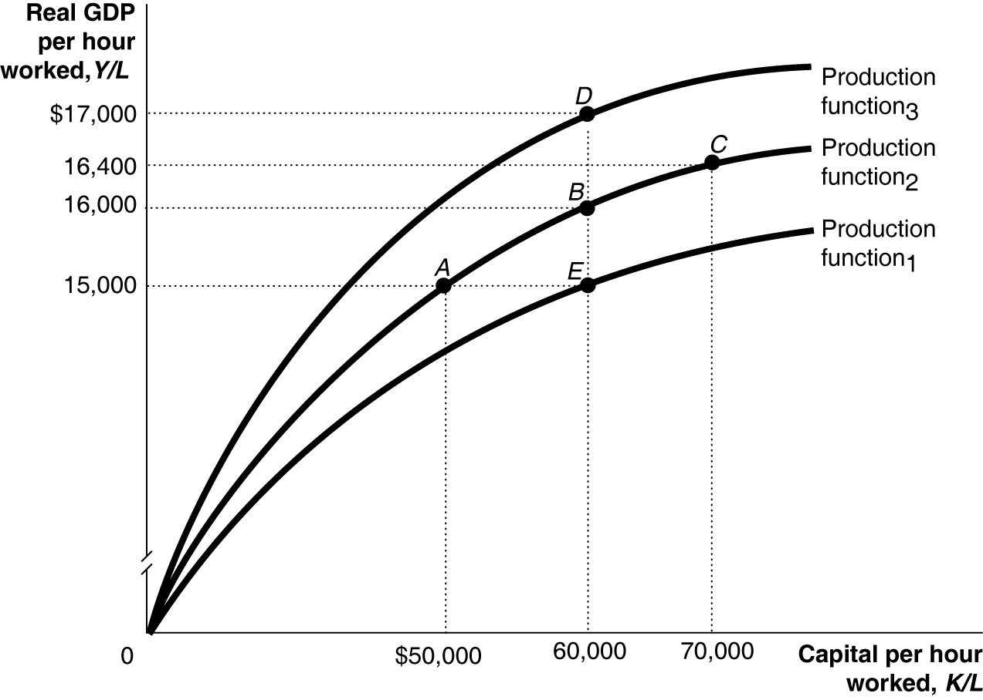

31) Refer to Figure 7.4. Suppose the economy gains more capital per hour worked and experiences technological change. This is shown in the figure above by the movement from
A) A to D. B) E to B to D. C) D to A. D) A to B to C. E) A to E.

32) Suppose that an increase in capital per hour worked from $15,000 to $20,000 increases real GDP per hour worked by $500. If capital per hour worked increases further to $25,000, by how much would you expect real GDP per hour worked to increase if there are diminishing returns?
A) by more than $5,000 but less than $20,000
B) by more than $20,000
C) by exactly $500
D) by less than $500
E) by more than $500 but less than $5,000

33) Which of the following policies are designed specifically to directly promote technological change in an economy?
A) tax incentives to promote investment in RRSP plans
B) policies to protect domestic businesses from foreign direct investment
C) a vaccination program to combat infectious diseases
D) laws to strengthen property rights
E) government subsidization of research and development

34) All of the following are reasons why China is unlikely to maintain high enough rates of productivity growth to catch up with the standard of living in the Canada except
A) the Chinese migration of rural workers to more productive urban jobs.
B) Canada invests more in research and development. than does China.
C) private firms have difficulty getting loans from state-owned banks that they need to expand production.
D) much of China's growth is likely due to the transition from a centrally-planned economy to a market economy.
E) because of the low birth rate in China, the labour force will soon decline.

35) The per-worker production function shows the relationship between ________ per hour worked and ________ per hour worked, holding ________ constant.
A) labour; real GDP; technology
B) capital; nominal GDP; labour
C) labour; capital; real GDP
D) capital; labour; real GDP
E) capital; real GDP; technology

36) If the growth rate of GDP is adjusted downward, and the number of hours worked upward, how will figures on the growth rate of labour productivity be adjusted?
A) The level will be adjusted downwards and the growth rate upwards.
B) The growth rate will not be adjusted.
C) The growth rate will be adjusted upwards.
D) The level will be adjusted upwards and the growth rate downwards.
E) The growth rate will be adjusted downwards.
37) Household wealth is defined as the value of a household's
A) assets.
B) credit rating.
C) assets plus the value of its liabilities.
D) assets minus the value of its liabilities.
E) liabilities.

38) A general formula for the multiplier is
A) . B) . C) . D) . E) .

39) ________ is defined as national income + transfers - taxes.
A) GDP
B) Gross private domestic investment
C) Personal income
D) Disposable income
E) Government deficit

40) The key idea of the aggregate expenditure model is that in any particular year, the level of GDP is determined mainly by
A) export spending.
B) investment spending.
C) household savings.
D) the level of aggregate expenditure.
E) government spending.

41) The marginal propensity to consume is defined as
A) consumption divided by disposable income.
B) the change in disposable income divided by the change in consumption.
C) disposable income divided by consumption.
D) consumption divided by gross income.
E) the change in consumption divided by the change in disposable income.

42) National income =
A) Consumption + Saving - Taxes.
B) Consumption + Saving - Net Exports
C) Consumption + Saving + Taxes.
D) Consumption - Saving - Taxes.
E) Consumption + Saving + Net Exports

43) Assume disposable income increases by 10000 and consumption increases by 8500. What is the value of MPC?
A) 0.85 B) 0.9 C) 0.5 D) 0.15 E) 0.95

44) Actual investment spending includes spending by consumers on
A) services.
B) durable goods.
C) stocks and bonds.
D) nondurable goods.
E) new houses.

45) The decrease in consumer spending during the 2008-2009 recession was due in part to falling prices in the stock market. The reason for the decline in consumer spending is most closely related to which of the following variables that determine the level of consumption?
A) household wealth
B) the interest rate
C) government transfers
D) current disposable income
E) the price level

46) Actual investment spending does not include
A) changes in the number of factories.
B) spending on consumer durable goods.
C) planned changes in inventories.
D) spending on new capital equipment.
E) spending on new houses.

47) The aggregate expenditure model focuses on the relationship between ________ and ________ in the short run, assuming ________ is constant.
A) total income; real GDP; the price level
B) total spending; real GDP; total income
C) total production; nominal GDP; unemployment
D) total production; total income; real GDP
E) total spending; real GDP; the price level

48) If firms sell exactly what they expected to sell, all of the following will be true except
A) inventories will not change, and GDP and employment will remain stable.
B) unplanned investment will be zero.
C) there is no unplanned change in inventories.
D) aggregate expenditure will be equal to GDP.
E) aggregate expenditure will be greater than GDP.
49) Given the equations for C, I, G, and NX below, what is the marginal propensity to save?

C = 1,000 + 0.8Y
I = 1,500
G = 1,250
NX = 100

A) 0.1 B) 0.2 C) 0.8 D) 1.8 E) 10

50) The slope of the consumption function is equal to
A) the change in consumption divided by the change in disposable income.
B) the change in disposable income divided by the change in consumption.
C) the change in consumption divided by the change in personal income.
D) the change in saving divided by the change in disposable income.
E) the change in national income divided by the change in consumption.

51) An increase in the price level results in a(n) ________ in household consumption spending and causes investment spending to ________.
A) decrease; decrease
B) decrease; increase
C) decrease; remain constant
D) increase; increase
E) increase; decrease

52) If the consumption function is defined as C = 5,500 + 0.9Y, what is the value of the multiplier?
A) 0.1 B) 0.9 C) 2 D) 9 E) 10

53) Macroeconomic equilibrium occurs when
A) aggregate expenditure = C+ I + G + net transfers.
B) aggregate income = planned inventories.
C) aggregate expenditure = planned inventories.
D) exports = imports.
E) aggregate expenditure = GDP.

54) The Conference Board of Canada's Consumer Confidence Index measures
A) consumers' expectations about the future.
B) the confidence Canadians have in the safety of the products they consume.
C) the confidence Canadians have in their relationships.
D) the confidence the public has in the federal government.
E) the confidence consumers have in banks.

55) What impact does a decrease in the price level in Canada have on net exports and why?
A) A decrease in the price level reduces net exports because lower prices reduce the value of the Canadian dollar making exports more costly.
B) A decrease in the price level increases net exports by reducing the relative cost of Canadian goods.
C) A decrease in the price level reduces net exports because lower prices increase American spending on imports.
D) A decrease in the price level increases net exports because lower prices increase the value of the dollar.
E) A decrease in the price level reduces net exports because lower prices raise the value of the dollar.

56) Assume you are given the following information about an economy.

C = 622 NX = 163 G = 422 I = 127

What is the equilibrium value of real GDP?
A) 1334 B) 1171 C) 1780 D) 912 E) 1980

57) Shelter is the largest component of the Canadian CPI market basket.
A) True
B) False

58) A period of economic expansion ends with a business cycle trough.
A) True
B) False

59) Inflation usually increases during a recession and decreases during an expansion.
A) True
B) False

60) At the end of an expansion, wages of workers are usually rising faster than prices.
A) True
B) False

61) Most economic growth in the world occurred between 1,000,000 BCE and 1300 CE.
A) True
B) False

62) One reason why many low-income countries experience low rates of growth is because of poor public education and health.
A) True
B) False

63) According to new growth theory, firms accumulate the efficient level of both physical and knowledge capital.
A) True
B) False

64) If planned aggregate expenditure is less than real GDP, some firms will experience unplanned increases in inventories.
A) True
B) False

65) If aggregate expenditure is less than GDP, then inventories rise and GDP falls.
A) True
B) False

